Op Amp Circuits for Noisy environments
MECH 421 LAB 4
Kyle Ah Von #57862609
2025

Abstract
This lab focuses on designing and implementing op amp circuits for signal processing in a non-contact optical distance sensor operating under noisy conditions. In Phase 1, a red LED transmitter and photodiode amplifier are constructed, followed by high-pass and AC amplification stages that isolate the modulated optical signal from ambient light. In Phase 2, rectifier and low-pass filter circuits are added to convert the AC waveform into a stable DC output proportional to distance, and the complete system is assembled and tested across the sensor’s operating range. In Phase 3, firmware for the MSP430FR5739 microcontroller is developed to digitize the conditioned signal, and a C# interface is built to acquire, display, and log measurements with real-time visualization and out-of-range detection. Calibration experiments map ADC output to physical distance, enabling conversion functions and resolution analysis. The lab provides practical experience in optical sensing, analog filtering, signal conditioning, microcontroller data acquisition, and user interface design, highlighting the importance of calibration and noise mitigation in reliable sensor systems.

Contents
Abstract 1
Components Required 3
Part 1: Optical Transmitter 3
1. Circuit Setup 3
2. Hardware Setup 4
Part 2: Photodiode Amplifier and High-Pass Filter 5
1. Circuit Setup 5
2. Determining the Resistor and Capacitor Values 5
Part 3: AC Amplifier with Low-Pass Filter 7
1. Circuit Setup 7
2. Determining resistor and capacitor values 7
Part4: Rectifier and Low-Pass Filter 9
1. Circuit Setup 9
2. Determining resistor and capacitor values 9
Part 5: Complete Circuit Assembly 11
Part 6: Firmware and C# Interface 12
1. C# Interface 12
1. Data Reception and Byte Recombination 13
2. Averaging and Conversion 13
Part 7: Calibration and Resolution Measurement 13
1. Calibration Procedure 13
2. Conversion to Position 14
3. Resolution and Noise 15
Conclusion 16

Components Required
- Aluminum Extrusion
- Load Cell – Extrusion Attachment Plate
- Double Nut for Load Cell – Extrusion Attachment Plate
- M5x12 Screws
- Red LED Mount
- M5 Allen Key
- Red Optical LED
- Photodiode
- Set of resistors
- MCP6002 Opamps

Part 1: Optical Transmitter

Circuit Setup
A red LED is set up as shown below:
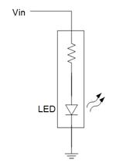
Figure 1: Circuit Schematic
Use the Analog Discovery 2 as a signal generator to make the LED flash to test if it works. Connect Vin to the red wire and ground to the black wire, then feed in a square wave with 5V amplitude and 2.5V DC offset.
Set the frequency to 1Hz and observe a flashing light… if it does not flash, check your connections or try a different LED.

Hardware Setup
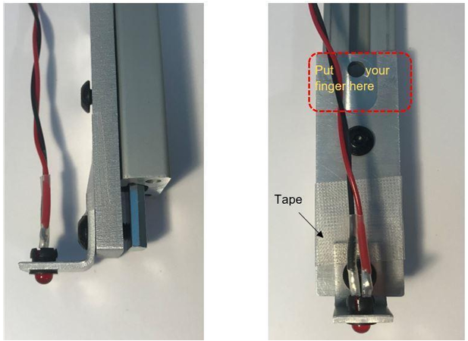
Figure 2: What the final product should look like
- Make sure the positioning screws are loosened so that the LED can move with the attachment plate.
- Use the tape to make sure that the LED Harness Mount doesn’t rotate. •While moving the LED away from the photodiode, do not touch anywhere close to the LED Harness Mount.
- Prop the breadboard up to match the height of the photodiode and the red LED.

Part 2: Photodiode Amplifier and High-Pass Filter

Circuit Setup
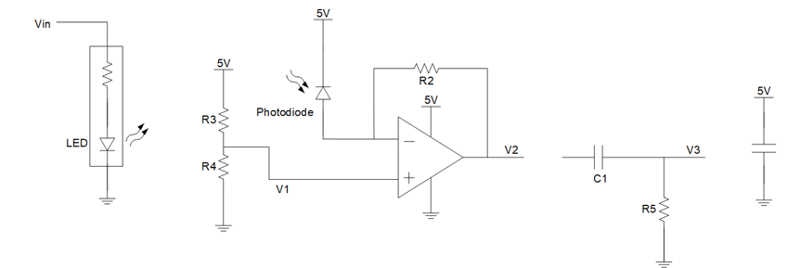
Figure 3: Photodiode amplifier and High-pass filter

Determining the Resistor and Capacitor Values
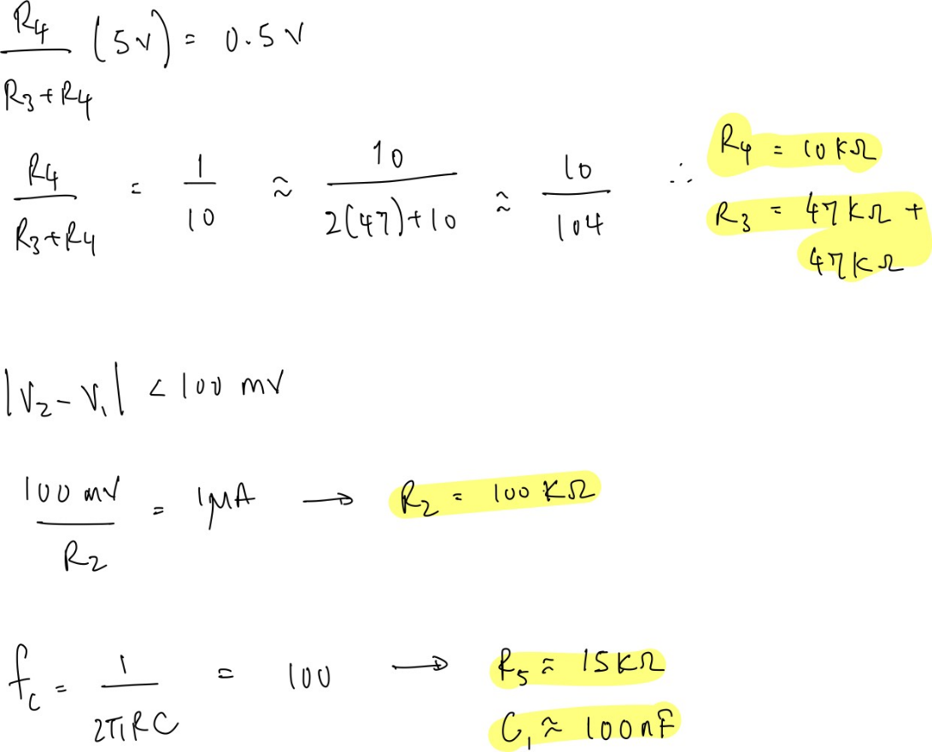
Figure 4: Calculations for R2, R3, R4, R5 & C1
R3 and R4 can be determined using the generic voltage divider equation:
$$\frac{R_{4}}{R_{4}+R_{3}}*5V=0.5V$$
R₂ can be determined by using the current draw of 1 milli Amp and the maximum allowed voltage difference of 100 mV.
Lastly, we can find a pair of resistor and capacitor values that satisfies the equation where the cutoff frequency is 100 Hz:
$$f_{c}=\frac{1}{2πRC}$$
While feeding in a square wave to Vin of the red LED, the values of the resistors above should yield the following signals at the corresponding probe locations.
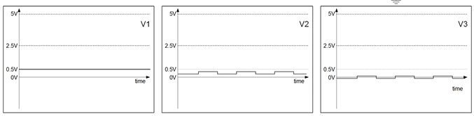
Figure 5: Expected wave signals
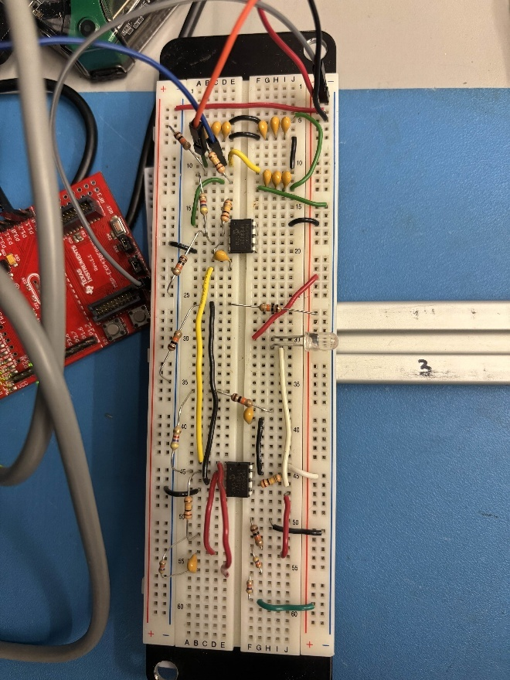
Figure 6: Breadboard circuit

Part 3: AC Amplifier with Low-Pass Filter

Circuit Setup
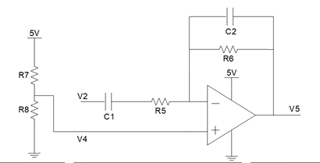
Figure 7:Amplifier Circuit & probe Voltage Signal

Determining resistor and capacitor values
C1 and R5 were determined from the previous section.
C2 and R6 form a low-pass filter, and the pair of values can be determined using this equation where the cutoff frequency is 16kHz:
$$f_{c}=\frac{1}{2πRC}$$
Yielding R6 = 15kΩ, and C2 = 68pF

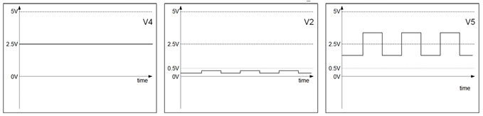
Figure 8: Expected signals at corresponding probe points
Figure 9: AC Amplifier Circuit

Part4: Rectifier and Low-Pass Filter

Circuit Setup
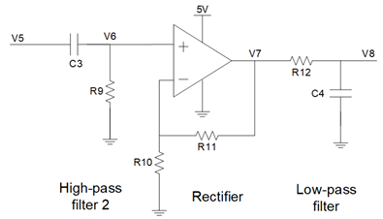
Figure 10: High-pass filter, rectifier, and low-pass filter

Determining resistor and capacitor values
To determine the pair of values for the High-pass filter, we can once again use the following equation where the cutoff frequency is 100Hz:
$$f_{c}=\frac{1}{2πRC}$$
Yielding C3 = 100nF and R9 = 15kΩ
R10 and R11 determine the gain of a standard non-inverting amplifier. In this case, the gain needs to be 11 using this equation:
$$\frac{V_{O}}{V_{I}}=1+ \frac{R_{11}}{R_{10}}$$
Yielding R10 = 1kΩ and R11 = 10kΩ
As for the low-pass filter with a cutoff frequency of 1.6Hz, we get C4 = 1µF and R12 = 1kΩ
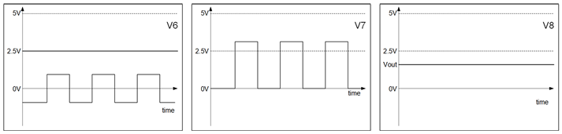
Figure 11: Signal at different probes
Figure 12: High-pass filter, Rectifier, and low-pass filter

Part 5: Complete Circuit Assembly
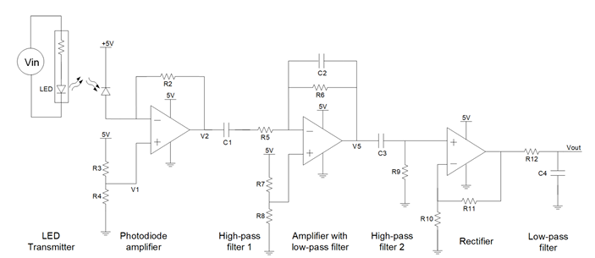
Figure 13: Final Circuit Schematic
The values of R10 and R11 need to be adjusted to ensure that Vout reads between 0 - 2.5V.
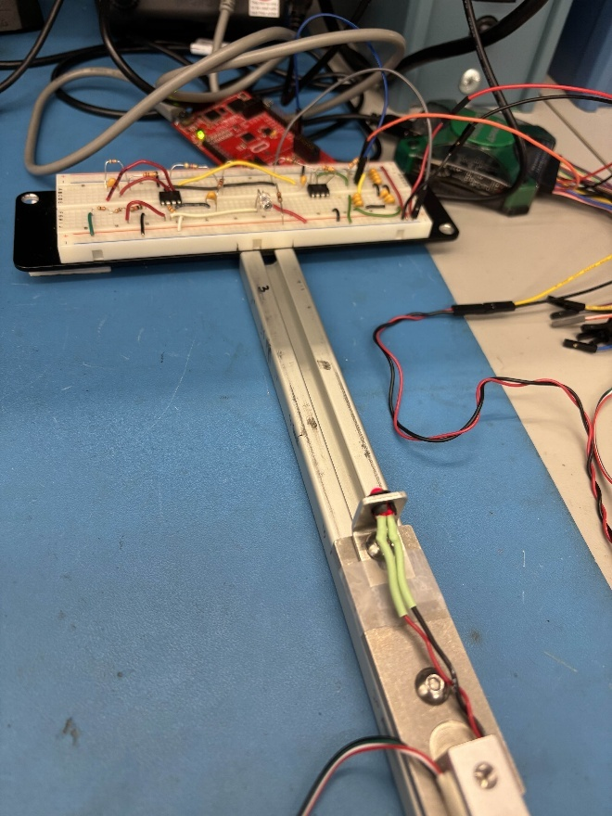
Figure 14: Full Setup

Part 6: Firmware and C# Interface

C# Interface
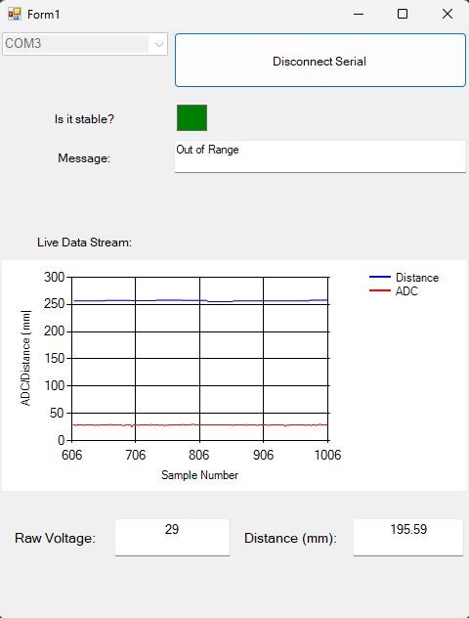
Figure 15: C# Interface
UI Features:
- Stability check indicator (This indicator shows whether the last 100 points are within 2 standard deviations)
- Message box that indicates if the red LED is out of range (30 mm – 215 mm)
- Live Data stream of both ADC values and the converted distance values
- Display instantaneous raw voltage and distance.

Data Reception and Byte Recombination
The MSP430 firmware transmits three bytes per sample:
- Lead byte (0xFF) – signals the start of a new data packet.
- HiByte – upper 5 bits of the 10‑bit ADC value.
- LoByte – lower 5 bits of the ADC value.
When the lead byte (255) is detected, the program expects the next byte to be the high part of the ADC value. The following byte is stored as MSB, then the next as LSB.
These are recombined into the full 10‑bit ADC count:
int combinedValue = ((MSB << 5) | LSB);

Averaging and Conversion
Once 20 samples have been collected (about 2s of data at 100ms per sample), the average is computed using .Average() on the queue.
The average ADC count is converted to distance using a fitted function discussed in the next section.

Part 7: Calibration and Resolution Measurement

Calibration Procedure
Record the ADC value against distance at 5 points:
ADC Value | Distance (mm)
652 | 30
403 | 50
125 | 100
64 | 150
41 | 200

Figure 16: Fitted Function

Conversion to Position
private double convertTomm(double rawVoltage) // Need to calibrate that....
{

return (2359.1 * Math.Pow(rawVoltage, -0.659)); // Convert to Celsius

}
Using this function, the ADC value can be mapped to a distance.

Resolution and Noise
During calibration, the actual measured distances are compared against the values reported by the software. Representative data points include:
- Actual = 100.0 mm → Reported = 94.82 mm
- Actual = 30.0 mm → Reported = 31.07 mm
- Actual = 210.0 mm → Reported = 213.5 mm
These results show that the sensor system consistently tracks distance but exhibits small deviations that vary across the operating range. The differences can be explained by several factors:
- Resolution limits of the ADC
  - The MSP430 digitizes the conditioned analog signal into 10-bit counts over a 0–3.3 V range. Each step corresponds to ~3.2 mV.
  - Near mid-range distances, small voltage changes map smoothly into distance increments, so the reported values closely match the actual (e.g., 30 mm vs. 31.07 mm).
  - At longer ranges, the slope of the calibration curve flattens, so each ADC step corresponds to a larger change in distance. This reduces effective resolution and can cause reported values to overshoot (e.g., 210 mm vs. 213.5 mm).
- Noise and averaging effects
  - Ambient light fluctuations, thermal noise in the photodiode, and supply ripple introduce jitter in the raw signal.
  - The C# program averages multiple samples to smooth the readout, but averaging can bias the reported value slightly above or below the true measurement depending on the distribution of noise.
  - At short distances, the signal amplitude is higher, so the relative impact of noise is smaller. At longer distances, the signal is weaker, and noise contributes more to the deviation.
- Fitting and calibration error
- The conversion from ADC counts to distance relies on a fitted function. Even with a good fit, residual error exists because the optical response is not perfectly linear.
- At 100 mm, the reported value undershoots (94.82 mm), reflecting a local mismatch between the calibration curve and the actual sensor response.
- At 210 mm, the reported value overshoots (213.5 mm), consistent with the curve fitting slightly overestimating distance at the far end of the range

Conclusion
This lab demonstrates how op amp circuits enable reliable optical distance sensing in noisy environments. By combining the LED transmitter, photodiode amplifier, filtering, rectification, and low-pass stages, the system converts a weak modulated signal into a stable DC output. Integrating the MSP430 firmware and C# interface allows real-time acquisition, visualization, and out-of-range detection. Calibration shows that the sensor tracks distance effectively, though resolution and noise vary across the range—errors are smaller at mid-range and larger near the extremes due to ADC quantization, weaker signals, and curve-fitting limits. Overall, the lab highlights the importance of signal conditioning, calibration, and software integration in building robust mechatronic instrumentation.

